10 SIMPLE WAYS TO FIND HAPPINESS/EMOTIONAL FULFILLMENT

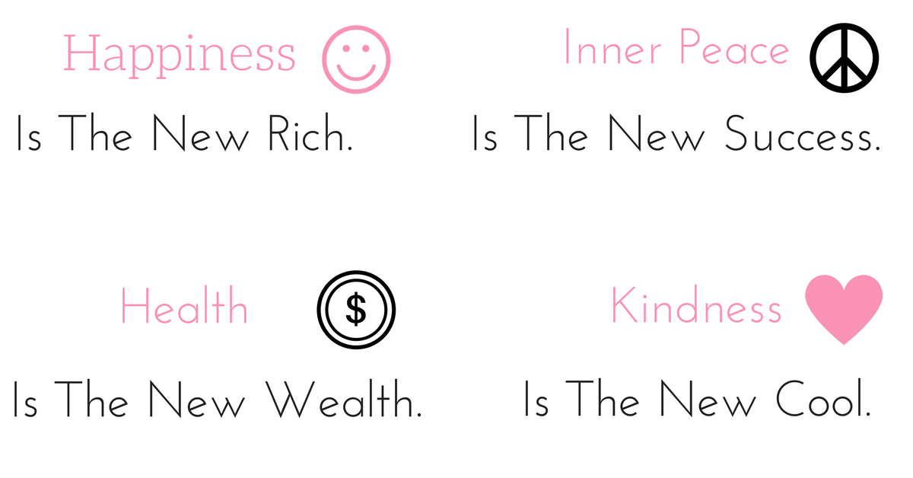
We all want to feel happy, and each one of us has different ways of getting there. Here are 10 steps you can take to increase your joy and bring more happiness into your life:

- Be with others who make you smile. Studies show that we are happiest when we are around those who are also happy. Stick with those who are joyful and let rub off on you.
- Hold on to your values. What you find true, what you know is fair, and what you believe in are all values. Over time, the more you honor them, the better you will feel about yourself and those you love.
- Accept the good. Look at your life and take stock of what’s working, and don’t push away something just because it isn’t perfect. When good things happen, even the very little ones, let them in.
- Imagine the best. Don’t be afraid to look at what you really want and see yourself getting it. Many people avoid this process because they don’t want to be disappointed if things don’t work out. The truth is that imagining getting what you want is a big part of achieving it.
- Do things you love. Maybe you can’t skydive every day or take vacations every season, but as long as you get to do the things you love every once in a while, you will find greater happiness.
- Find purpose. Those who believe they are contributing to the well-being of humanity tend to feel better about their lives. Most people want to be part of something greater than they are, simply because it’s fulfilling.
- Listen to your heart. You are the only one who knows what fills you up. Your family and friends may think you’d be great at something that really doesn’t float your boat. It can be complicated following your bliss. Just be smart and keep your day job for the time being.
- Push yourself, not others. It’s easy to feel that someone else is responsible for your fulfillment, but the reality is that it is really your charge. Once you realize that, you have the power to get where you want to go. Stop blaming others or the world, and you’ll find your answers much sooner.
- Be open to change. Even if it doesn’t feel good, change is the one thing you can count on. Change will happen, so make contingency plans and emotionally shore yourself up for the experience.
- Bask in the simple pleasures. Those who love you, treasured memories, silly jokes, warm days, and starry nights—these are the ties that bind and the gifts that keep on giving.
Happiness and fulfillment are within your grasp, but sometimes just out of reach. Understanding what works best for you is the first step in finding more of them.

